# CS 255 System Design Document Template

This template lays out all the different sections that you need to complete for Project Two. Each section has guidance to prompt your thinking. You will need to continually reference the interview transcript as you work to make sure that you are addressing your client’s needs. There is no required length for the final document. Instead the goal is to complete each section based on what your client’s needs are. Remove this note when you are finished, and replace all bracketed text with the relevant information.

## UML Diagrams

### UML Use Case Diagram

The Use Case Diagram represents the interactions between the DriverPass system and its primary actors, including the Customer, Secretary, IT Officer, and Owner. It highlights the functionalities of making, modifying, and canceling reservations, managing roles and rights, generating reports, and accessing DMV updates.

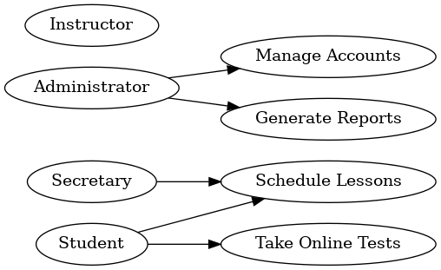

### UML Activity Diagrams

**Customer Reservation Workflow**

This diagram illustrates the steps a customer follows to make a reservation, including logging in, selecting an available time, entering reservation details, and confirming the reservation.

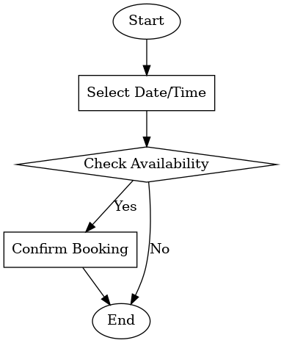

This diagram highlights the streamlined workflow for completing an online test and ensures that the process is clear, efficient, and user-friendly.

### UML Sequence Diagram

The Sequence Diagram details the step-by-step interaction for a customer making a reservation. It shows how the customer communicates with the system and how the system interacts with the database to validate credentials, check availability, and save the reservation.

**

### UML Class Diagram

The Class Diagram provides an overview of the key classes in the DriverPass system, including their attributes and relationships. Key classes are:  
- User: Represents the different system users (e.g., Customer, IT Officer, Secretary).  
- Reservation: Stores reservation details.  
- Package: Defines the available driving packages.  
- Driver: Represents driving instructors.  
- Car: Includes details about vehicles used for training.

## Technical Requirements

Based on the system design diagrams and the client’s requirements, the following technical specifications outline the necessary hardware, software, tools, infrastructure, and security considerations:

**Hardware Requirements:**

**Cloud Servers:**

* + Cloud-based servers with scalable storage and computer capabilities (AWS, Microsoft Azure, or Google Cloud) to host the DriverPass system.
  + High-speed processors and SSD storage for efficient handling of user data and transactions.

**User Devices:**

* + Desktop computers, laptops, or mobile devices capable of running modern web browsers (Chrome, Firefox, Safari).
  + Recommended hardware specifications for end users include a minimum of 4GB RAM, dual-core processors, and stable internet connectivity.

**Software Requirements:**

**Operating Systems:**

* + For servers: Linux-based OS (Ubuntu, CentOS) for reliability and cost-effectiveness.
  + For user devices: Cross-platform compatibility with Windows, macOS, Android, and iOS.

**Web Server:**

* + Apache HTTP Server or Nginx to host web pages and API endpoints.

**Database:**

* + MySQL or PostgreSQL for managing relational data, including user accounts, lesson schedules, and test results.

**Programming Frameworks:**

* + Python (with Django or Flask) or Java (with Spring Boot) for backend development.
  + HTML, CSS, and JavaScript for front-end development (e.g., React or Angular).

**Web Browsers:**

* + Fully compatible with modern browsers such as Google Chrome, Mozilla Firefox, and Microsoft Edge.

**Tools:**

**Diagram Tools:**

* + Lucidchart or Microsoft Visio for creating UML diagrams such as use case, activity, sequence, and class diagrams.

**Development Tools:**

* + Git for version control to manage source code collaboratively.
  + Selenium for automated UI and functional testing.

**Security Monitoring Tools:**

* + Firewall systems (Cisco ASA or Fortinet) for network protection.
  + Real-time monitoring tools like Splunk or Datadog to detect and log suspicious activity.

**IDE Tools:**

* + Visual Studio Code, IntelliJ IDEA, or PyCharm for efficient development.

**Infrastructure Requirements:**

**Hosting:**

* + Cloud-based hosting platform for high availability and scalability.
  + Load balancers to distribute incoming traffic efficiently.

**Network:**

* + High-speed internet with backup redundancy for consistent uptime.
  + Secure VPN for administrative access to backend servers.
* **Storage:**
  + Cloud storage solutions to handle lesson materials, online test data, and user files.
* **Backup:**
  + Automated backups with a retention policy to ensure data recovery in case of failures.

**Security Requirements:**

* **Role-Based Access Control (RBAC):**
  + Ensure users have appropriate access levels based on their roles (Administrator, Instructor, Secretary, Student).
* **Data Encryption:**
  + Encrypt sensitive data, such as passwords and payment information, using industry standards like AES and TLS.
* **Authentication and Authorization:**
  + Implement multi-factor authentication (MFA) for users to enhance security.
* **Compliance:**
  + Regular updates to maintain compliance with DMV requirements and data privacy regulations (GDPR, CCPA).
* **Monitoring and Alerts:**
  + Real-time system monitoring with tools like Splunk to detect unauthorized access or suspicious activities.
  + Firewall solutions for advanced threat protection and intrusion detection.

These technical requirements ensure the DriverPass system operates efficiently, securely, and reliably while meeting client expectations.